Project Design Phase-II Technology Stack (Architecture & Stack)

NM2023TMID00931

Date 24 october 2023

|  |  |
| --- | --- |
| Date | 03 NOV 2023 |
| Team ID | NM2023TMID04368 |
| Project Name | Data-Driven Insights on Olympic Sports Participation and Performance |
| Maximum Marks | 4 Marks |

**Technical Architecture:**

The Deliverable shall include the architectural diagram as below and the information as per the table1 & table 2

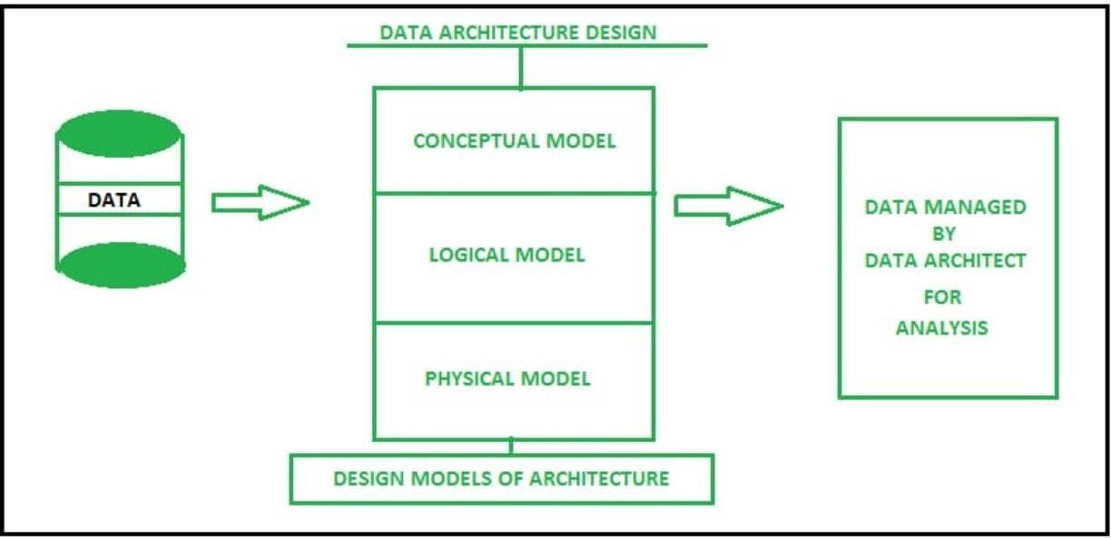

Guidelines:

1. Include all the processes (As an application logic / Technology Block)2. Provide infrastructural demarcation (Local / Cloud)

1. Indicate external interfaces (third party API’s etc.)
2. Indicate Data Storage components / services
3. Indicate interface to machine learning models (if applicable)

**Table-1 : Components & Technologies:**

|  |  |  |  |
| --- | --- | --- | --- |
| **S.No** | **Component** | **Description** | **Technology** |
| 1. | User Interface | User can enter the dataset as a pdf , doc ,  Excel sheets ... Into the program | HTML, CSS, JavaScript / Angular Js /  React Js etc. |
| 2. | Application Logic-1 | Greater than or lesser than | Java / Python |
| 3. | Application Logic-2 | Comparing the literacy rate of each other  States , districts and cities. | Java / python |
| 4. | Application Logic-3 | Finding the change over time | Java / python |
| 5. | Database | MongoDB | MySQL, NoSQL, etc. |
| 6. | Cloud Database | IBM cloud | IBM DB2, IBM Cloudant etc. |
| 7. | File Storage | File must be stored as a pdf , doc etc... | IBM Block Storage or Other Storage Service or Local Filesystem |
| 8. | External API-1 | Extracting possible datasets from internet | IBM Cloud et c. |
| 9. | External API-2 | Using to display the datasets | Tableau.. etc |
| 10. | Machine Learning Model | Machine learning model for predictive analysis | Analysis Model, etc. |
| 11. | Infrastructure (Server / Cloud) | Application Deployment on Local System / Cloud  Local Server Configuration:localhost  Cloud Server Configuration : IBM clud | Local, Cloud Foundry, Kubernetes, etc. |

**Table-2: Application Characteristics:**

|  |  |  |  |
| --- | --- | --- | --- |
| **S.No** | **Characteristics** | **Description** | **Technology** |
| 1. | Open-Source Frameworks | Django , Flask | Technology of Opensource framework |
| 2. | Security Implementations | Security policy and Transport layer security | e.g. SHA-256, Encryptions, IAM Controls, OWASP etc. |
| 3. | Scalable Architecture | Micro services architecture | Technology used |